Staging Area / Index

Definition
# Source: AI Source: Provided by: [Data Path: Persons Table -> ID Column: 1, Name_En Column: Motasem Essam] -> From: [ChatGPT] on [2/15/2026]
The Staging Area (also called the Index) is the place where you prepare changes before saving them permanently (commit) into the repository.
It acts like a waiting room between your Working Directory and the Repository.

Is Staging Area being main folder for all project or folder that has files you work on it only?

Short answer:
# Source: AI Source: Provided by: [Data Path: Persons Table -> ID Column: 1, Name_En Column: Motasem Essam] -> From: [ChatGPT] on [2/15/2026]
❌ The Staging Area is NOT a folder (not a real directory like your project folder).
✔️ It is an internal Git area that stores a snapshot of selected changes only.

Clear explanation
# Source: AI Source: Provided by: [Data Path: Persons Table -> ID Column: 1, Name_En Column: Motasem Essam] -> From: [ChatGPT] on [2/15/2026]
- The Working Directory = your real project folder (all files).
- The Staging Area = a virtual layer inside Git that holds only the files/changes you choose for the next commit.
So:
👉 It is NOT the main project folder
👉 It is NOT a folder you open or work inside
👉 It only contains selected changes, not the whole project

Example
# Source: AI Source: Provided by: [Data Path: Persons Table -> ID Column: 1, Name_En Column: Motasem Essam] -> From: [ChatGPT] on [2/15/2026]
Project folder (Working Directory):
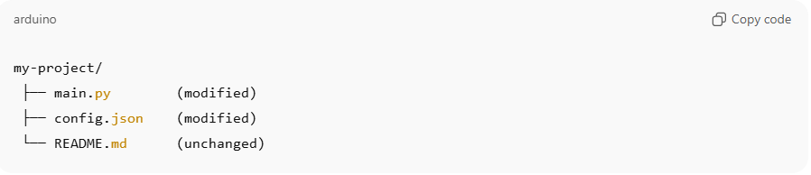
my-project/
├── main.py (modified)
├── config.json (modified)
└── README.md (unchanged)

Now you run:
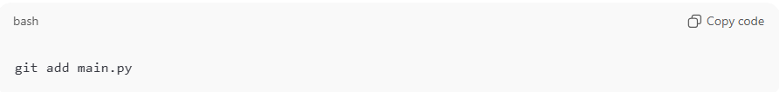
git add main.py

What happens:
- Staging Area now contains only main.py
- config.json is NOT staged
- README.md unchanged (not staged)
So the Staging Area does not contain the whole project, only what you added.

Important concept
# Source: AI Source: Provided by: [Data Path: Persons Table -> ID Column: 1, Name_En Column: Motasem Essam] -> From: [ChatGPT] on [2/15/2026]
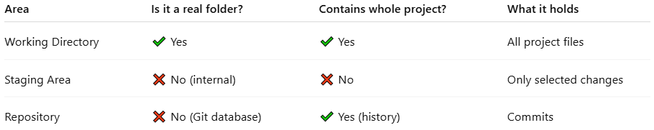
Area | Is it a real folder? | Contains whole project? | What it holds
Working Directory | ✔ Yes | ✔ Yes | All project files
Staging Area | ❌ No (internal) | ❌ No | Only selected changes
Repository | ❌ No (Git database) | ✔ Yes (history) | Commits

Simple memory trick
# Source: AI Source: Provided by: [Data Path: Persons Table -> ID Column: 1, Name_En Column: Motasem Essam] -> From: [ChatGPT] on [2/15/2026]
- Working Directory → where files LIVE
- Staging Area → what you CHOOSE
- Repository → what you SAVE

What exactly is the Staging Area?

Answer
# Source: AI Source: Provided by: [Data Path: Persons Table -> ID Column: 1, Name_En Column: Motasem Essam] -> From: [ChatGPT] on [2/15/2026]
The Staging Area (Index) is not a normal file, not a folder, and not something you edit.
It is:
👉 A special internal Git data structure
👉 Stored inside .git/index
👉 Acts like a temporary snapshot (record) of selected file changes
So the closest description is:
The Staging Area is a record (snapshot) of the files you chose for the next commit.

Is it a file?
# Source: AI Source: Provided by: [Data Path: Persons Table -> ID Column: 1, Name_En Column: Motasem Essam] -> From: [ChatGPT] on [2/15/2026]
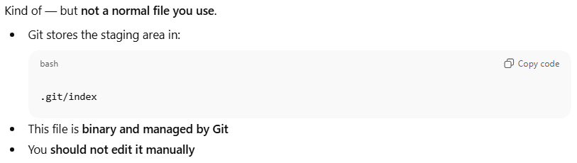
Kind of — but not a normal file you use.
- •Git stores the staging area in:
.git/index
- This file is binary and managed by Git•
- You should not edit it manually

What does it contain exactly?
# Source: AI Source: Provided by: [Data Path: Persons Table -> ID Column: 1, Name_En Column: Motasem Essam] -> From: [ChatGPT] on [2/15/2026]
The Staging Area stores metadata about staged files, such as:
- File path (name & location)
- File version (hash)
- Snapshot of file content at staging time
- File permissions
It does NOT store your whole project, only the files you staged with git add.

Example (what happens internally)
# Source: AI Source: Provided by: [Data Path: Persons Table -> ID Column: 1, Name_En Column: Motasem Essam] -> From: [ChatGPT] on [2/15/2026]
You edit:
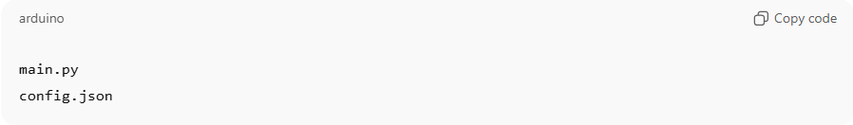
main.py
config.json
Then run:
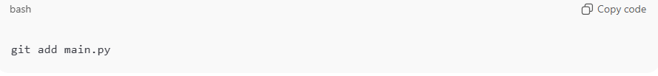
git add main.py
Now inside .git/index Git records:
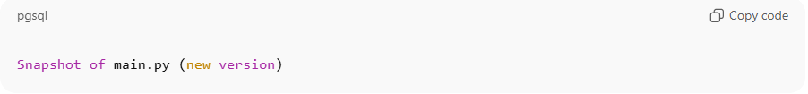
Snapshot of main.py (new version)
But config.json is NOT recorded, because you didn’t stage it.

Simple understanding
# Source: AI Source: Provided by: [Data Path: Persons Table -> ID Column: 1, Name_En Column: Motasem Essam] -> From: [ChatGPT] on [2/15/2026]
- Working Directory → real files you edit
- Staging Area → Git’s snapshot record of selected changes
- Repository → permanent history (commits)

One-line answer
# Source: AI Source: Provided by: [Data Path: Persons Table -> ID Column: 1, Name_En Column: Motasem Essam] -> From: [ChatGPT] on [2/15/2026]
Staging Area = a Git-managed snapshot record (stored in .git/index) of the files you selected for the next commit.

Simple idea
# Source: AI Source: Provided by: [Data Path: Persons Table -> ID Column: 1, Name_En Column: Motasem Essam] -> From: [ChatGPT] on [2/15/2026]
Staging Area = the list of changes you choose to include in the next commit.
You control it using git add.

How Git workflow works
# Source: AI Source: Provided by: [Data Path: Persons Table -> ID Column: 1, Name_En Column: Motasem Essam] -> From: [ChatGPT] on [2/15/2026]
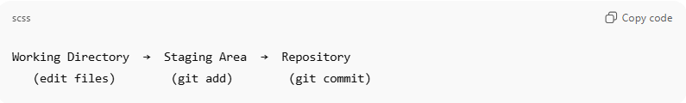
Working Directory → Staging Area → Repository
(edit files) (git add) (git commit)
- You edit files in Working Directory
- You select changes using Staging Area
- You save them permanently with Commit

Example
# Source: AI Source: Provided by: [Data Path: Persons Table -> ID Column: 1, Name_En Column: Motasem Essam] -> From: [ChatGPT] on [2/15/2026]
You change two files:
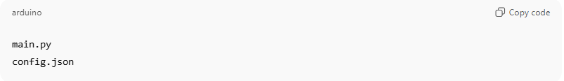
main.py
config.json
But you only want to commit main.py now:
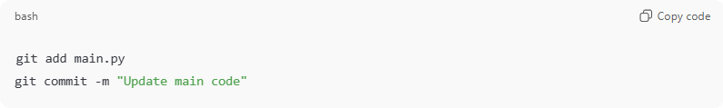
git add main.py
git commit -m "Update main code"
Result:
- main.py → saved in commit ✅
- config.json → NOT committed ❌ (still unstaged)
This is why the Staging Area is useful — you choose exactly what goes into a commit.

What the Staging Area does
# Source: AI Source: Provided by: [Data Path: Persons Table -> ID Column: 1, Name_En Column: Motasem Essam] -> From: [ChatGPT] on [2/15/2026]
- Collects selected changes
- Lets you split commits cleanly
- Prevents committing unwanted files
- Prepares the next snapshot of your project

Common commands
# Source: AI Source: Provided by: [Data Path: Persons Table -> ID Column: 1, Name_En Column: Motasem Essam] -> From: [ChatGPT] on [2/15/2026]
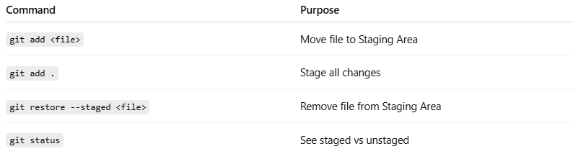
Command | Purpose
git add <file> | Move file to Staging Area
git add . | Stage all changes
git restore --staged <file> | Remove file from Staging Area
git status | See staged vs unstaged

Quick comparison
# Source: AI Source: Provided by: [Data Path: Persons Table -> ID Column: 1, Name_En Column: Motasem Essam] -> From: [ChatGPT] on [2/15/2026]
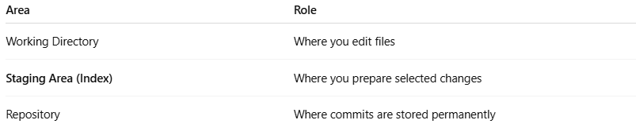
Area | Role
Working Directory | Where you edit files
Staging Area (Index) | Where you prepare selected changes
Repository | Where commits are stored permanently

One-line memory trick
# Source: AI Source: Provided by: [Data Path: Persons Table -> ID Column: 1, Name_En Column: Motasem Essam] -> From: [ChatGPT] on [2/15/2026]
Working Directory = edit → Staging Area = choose → Repository = save

